**DAILY ONLINE ACTIVITIES SUMMARY**

|  |  |  |  |  |  |  |  |  |
| --- | --- | --- | --- | --- | --- | --- | --- | --- |
| **Date:** | **24/06/2020** | | | | | **Name:** | **PRANEETA P HANDRAL** | |
| **Sem & Sec** | **4​th​ SEM. & ‘B’ SEC.** | | | | | **USN:** | **4AL19CS401** | |
| **Online Test Summary** | | | | | | | | |
| **Subject** | | **_ _ _** | | | | | | |
| **Max. Marks** | | **30** | | **Score** | | | **_ _** | |
| **Certification Course Summary** | | | | | | | | |
| **Course** | **Introduction to Cloud** | | | | | | | |
| **Certificate Provider** | | | **Cognitive class** | | **Duration** | | | **6 Hrs.** |
| **Coding Challenges** | | | | | | | | |
| **Problem Statement:** _ _ _ | | | | | | | | |
| **Status:** _ _ _ _ | | | | | | | | |
| **Uploaded the report in Github** | | | | | **Yes** | | | |
| **If yes Repository name** | | | | | **_ _ _ _ _** | | | |
| **Uploaded the report in slack** | | | | | **Yes** | | | |

**Online Test Summary:** No internals conducted.

**Online Certification course Summary​:** I have taken my Online Certification Course in **Cognitive class**  the course which I have opted is **Introduction to Cloud**. Course contains videos, tutorials, assessments and quiz. Today I have gone throw **Overview of Cloud Computing** and **Key Considerations for Cloud Computing.**

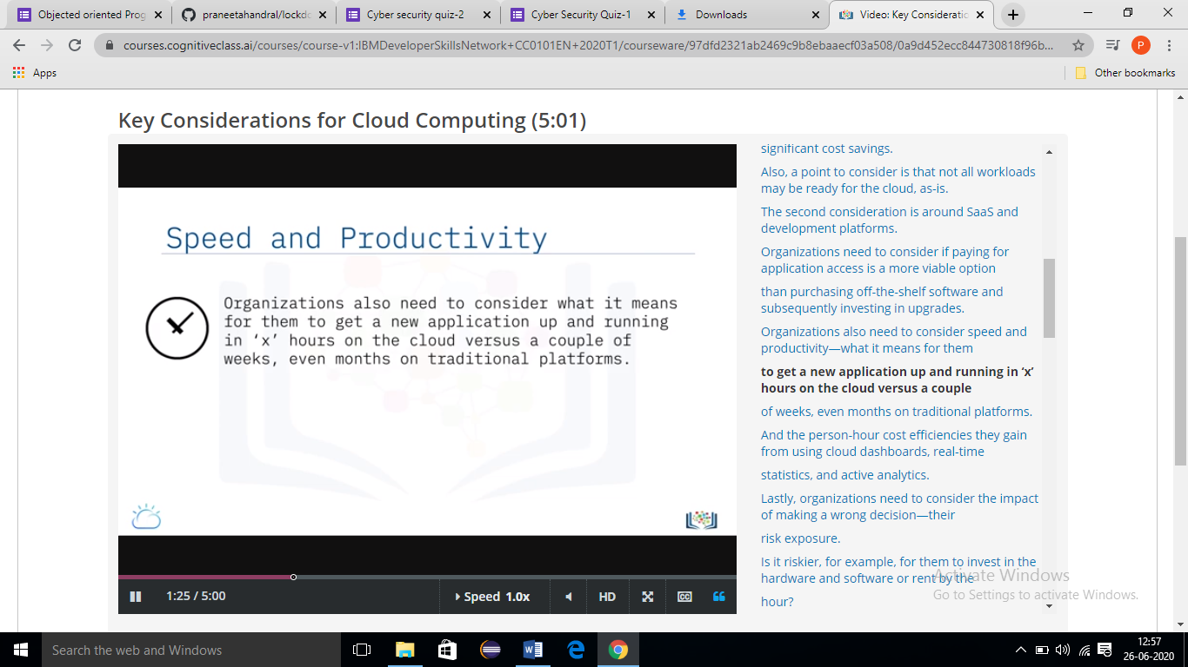

**Online Training:-** Today I had attended the online training organized by CSE Dept AIET. The training was on C programming done by Prof. Megha D. Hegde CSE Dept.